**Assignment No. 3**

* ***Aim:***

Measurement of basic electrical parameters using multimeters, panel meters, and clamp meters.

* ***Apparatus:***

Multimeters, panel meters, clamp meters, single phase connection, 3- phase connection

* ***Objective:***

1.To demonstrate the configuration and setup of digital meters to measure the electrical parameters.

* ***Outcome:***

Students will be able to:

1. Configure/Setup and use instruments/digital meters to measure electrical parameters.

* ***Theory:***

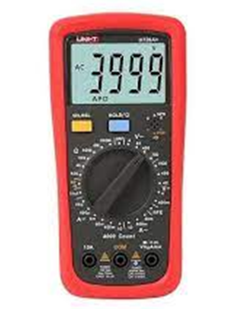Measuring basic electrical parameters is a fundamental aspect of working with electrical systems. Multimeters, panel meters, and clamp meters are common tools used for this purpose.

* **Multimeters:**

A multimeter, also known as a volt-ohm meter or VOM, is a versatile handheld electronic instrument used to measure various electrical quantities such as voltage, current, resistance, and continuity in an electrical circuit.

* 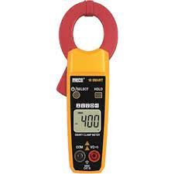**Panel Meters:**

Panel meters are instruments used to display various electrical parameters such as voltage, current, frequency, power, etc., in control panels or electrical equipment.

* **Clamp Meter:**

A clamp meter, also known as a clamp-on ammeter or tong tester, is an electrical testing device used to measure current without the need to physically disconnect the wires. It clamps around the conductor, allowing measurement of current flow without breaking the circuit.

* ***Images:***

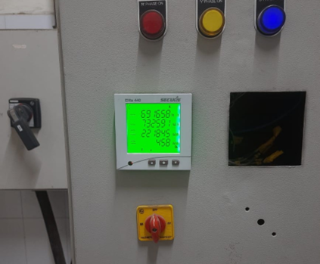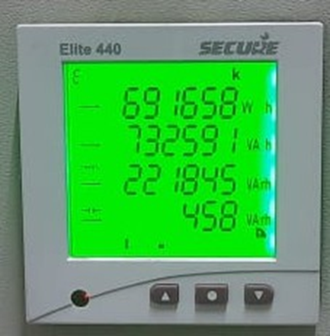

**Figure 1: Panel Meter at AISSMS IOIT ELECTRICAL ROOM**

* ***Conclusion:***

Studied to measure basic electrical parameters using panel meter, multimeter, clamp meter.